Anonymous Lecture Attendance Tracking using Thermal Camera

Kieran Hitchcock

# Abstract

**This paper proposes a method to fuck your mym**

# Introduction

Tracking the lecture theatre attendance can be used to determine how well the theatre is being utilized. This can allow the theatres to be optimised such as moving poorly attended classes to smaller lecture theatres to free up the larger and more useful theatres. Furthermore, it can be used to track room occupancy and changing the lighting or heating accordingly.

Typically, colour cameras have been used to predict the number of people present in crowds. However, colour cameras require high-resolution images for accurate prediction. This means the distinguishing features, and therefore individual people, can be tracked. This would be an invasion of the student privacy and could be unethical to set up in every lecture theatre.

Thermal cameras detect body heat in the form of infrared radiation. This means that thermal cameras work independently of visible light conditions, unlike colour cameras. Additionally, the thermal camera would not be affected by the colour of clothing and as complicated image classification is not required, the image processing can be less intensive with thermal camera.

Very low-resolution thermal cameras, such as a Passive Infrared (PIR) sensor, can be used to detect moving people. However, these cameras cannot detect individuals in a lecture theatre. Therefore, they are typically used over doorways to count people entering and leaving [8], [5], [7]. This would this would require multiple cameras per lecture theatre and would not provide any positional information of the occupants in the room. Therefore, it would be better to use a single, higher resolution thermal camera that could capture an entire lecture theatre and count individuals.

A range of studies have looked at using high resolution thermal cameras to count people in crowded areas [][][]. As thermal cameras are very expensive compared to colour cameras, using the lowest resolution thermal camera possible would make the concept more viable. Additionally, the lower resolution also reduces the possibility of any unique/distinguishing features of people being identified to preserve anonymity.

This paper proposes a method to use a single Lepton 3 thermal camera to estimate the number of people present in a theatre. This paper firstly outlines some of the previous research into this field and how it can be implemented to create a functioning program. Next, there is a summary of the method used count lecture attendance. Finally, this paper compares how well this method worked compared to similar attempts and indicates where improvements to the method developed could be made.

# Background

A number of papers have looked at using thermal cameras to detect and count people, but none were found that focused on lecture theatre attendance.

The Lepton 3 camera used in this __ has a resolution of 160x120 pixels which is relatively low-resolution compared to the size of the lecture theatre. Therefore, the background research mostly focused studies using low-resolution cameras

In the paper “*Room occupancy measurement using low-resolution infrared cameras*” [1], a 16x16 pixel thermal camera is used to count the number of people in a small room. The methodology is outlined in Figure __.

Limitations of this study:

This study used a top-down view to try to minimize the blob merging and to ensure that people will create equal sized blobs. The biggest limitation using thermal camera for people counting is the tendency for the heat blobs of people to merge together. This merging, as shown in Figure __ makes it difficult to accurately predict the number of people.

However, the method is good.

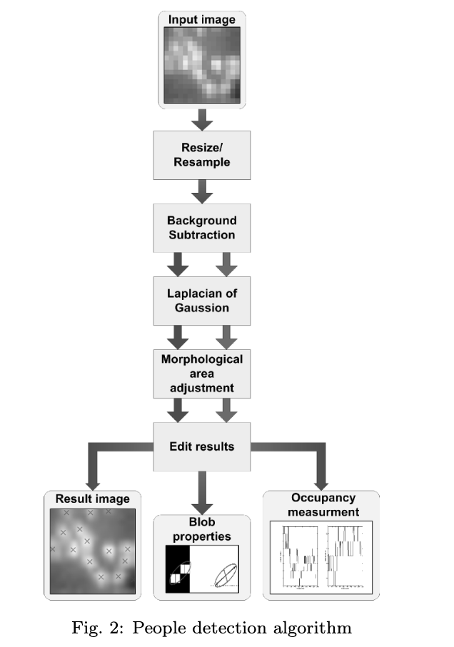

## Blob Separation

### Colour Camera

Some projects use colour cameras in conjunction with thermal cameras to separate the blobs.

### Neural Networks

This project [2] used a neural network on the both the thermal and colour images to identify how many people were present. This was not suitable as it required a large amount of training data and only worked in a fixed environment. Therefore, it is unlikely that it would work in a variety of lecture theatres. Although this project did only use a top down view in order to minimize blob merging, the neural network method could still be implemented in a front on view of a lecture theatre.

### Genetic Algorithm

In larger crowds, colour cameras tend to have similar problems as thermal cameras where people begin to form indistinguishable blobs and begin to merge together. One paper [3], uses a genetic algorithm to

### Watershed

### Ellipse Fitting

## Contour Detection

# Propose Method

Face the front in order to get an accurate picture of all of the entire theatre. (angle of camera)

* Flow Diagram

# Results

* Images
* False positives
* Missed points

# Conclusion

# References (15-25)

[1]

<https://www.researchgate.net/publication/224195975_Room_occupancy_measurement_using_low-resolution_infrared_cameras>

[2]

<http://free-journal.umm.ac.id/files/file/015_8123am0803_133_140.pdf>

[2]

<https://www.semanticscholar.org/paper/Automated-people-counting-by-using-low-resolution-Amin-Taylor/f9a0ed833ef9acdf529034df7aa2e341649d88b5>

[3]

<https://pdfs.semanticscholar.org/b5d5/ba0652078dcf7540c538b92218d33145dbc1.pdf>

[5]

<https://www.axis.com/en-nz/products/axis-people-counter>

[6]

<https://vbn.aau.dk/ws/portalfiles/portal/232810660/IJCAT53401_Gade_et_al.pdf>

[7]

<https://www.libraryplus.co.nz/item/241/people_counters/thermal-people-counter>

[8]

<http://www.bu.edu/vip/files/pubs/reports/JIEL17-03buece.pdf>

Extra shit removed

They use the thermal camera to detect whether a person/people are present and the colour camera to determine where the person/people are located within the image. As the colour camera can identify unique/distinguishing features, it is not suitable for use in the lecture theatres. Therefore, this exact method was excluded.

## Entrance Tracking

Some studies have looked to track people moving in and out of doorways using thermal cameras. This method is very successful and has a number of commercial products. Although this method is effective and could use cheaper, lower resolution thermal cameras, it would require multiple cameras for each door of a lecture theatre. Has limitations as it would not provide any positional information of the occupants within the room.

## Moving Crowds

Other studies have looked at using background subtraction (and double subtraction) with thermal cameras to count moving crowds with accuracy of up to 98% [2], [6]. However, once the students are seated, they are mostly stationary. Therefore, background subtraction would likely not give an accurate count. Furthermore, these projects have a lot of problems when people stand behind each other, causing their images to become intertwined.

Good links that need sorting

<https://pdfs.semanticscholar.org/37b9/e541a763a4a5d12187a43cc9599be0f7aeb3.pdf?_ga=2.154461240.1666350948.1559962877-349746408.1558845342>

High resolution

<https://www.preprints.org/manuscript/201811.0156/v1>